

Semester Two Examination, 2021

Question/Answer booklet

MATHEMATICS  
METHODS  
UNITS 1&2

Section Two:  
Calculator-assumed

Your name

|  |  |
| --- | --- |
| Number of additional answer booklets used (if applicable): |  |

## Time allowed for this section

Reading time before commencing work: ten minutes

Working time: one hundred minutes

## Materials required/recommended for this section

***To be provided by the supervisor***

This Question/Answer booklet

Formula sheet (retained from Section One)

***To be provided by the candidate***

Standard items: pens (blue/black preferred), pencils (including coloured), sharpener,  
correction fluid/tape, eraser, ruler, highlighters

Special items: drawing instruments, templates, notes on two unfolded sheets of A4 paper, and up to three calculators, which can include scientific, graphic and Computer Algebra System (CAS) calculators, are permitted in this ATAR course examination

## Important note to candidates

No other items may be taken into the examination room. It is **your** responsibility to ensure that you do not have any unauthorised material. If you have any unauthorised material with you, hand it to the supervisor **before** reading any further.

## Structure of this paper

|  |  |  |  |  |  |
| --- | --- | --- | --- | --- | --- |
| Section | Number of questions available | Number of questions to be answered | Working time (minutes) | Marks available | Percentage of examination |
| Section One: Calculator-free | 8 | 8 | 50 | 52 | 35 |
| Section Two: Calculator-assumed | 13 | 13 | 100 | 98 | 65 |
|  | | |  | **Total** | 100 |

|  |  |  |
| --- | --- | --- |
| Markers use only | | |
| Question | Maximum | Mark |
| 9 | 5 |  |
| 10 | 4 |  |
| 11 | 9 |  |
| 12 | 8 |  |
| 13 | 7 |  |
| 14 | 8 |  |
| 15 | 7 |  |
| 16 | 6 |  |
| 17 | 10 |  |
| 18 | 8 |  |
| 19 | 7 |  |
| 20 | 10 |  |
| 21 | 9 |  |
| S2 Total | 98 |  |
| S2 Wt (×0.6633) | 65% |  |

## Instructions to candidates

1. The rules for the conduct of examinations are detailed in the school handbook. Sitting this examination implies that you agree to abide by these rules.

2. Write your answers in this Question/Answer booklet preferably using a blue/black pen.  
Do not use erasable or gel pens.

3. You must be careful to confine your answers to the specific question asked and to follow any instructions that are specific to a particular question.

4. Show all your working clearly. Your working should be in sufficient detail to allow your answers to be checked readily and for marks to be awarded for reasoning. Incorrect answers given without supporting reasoning cannot be allocated any marks. For any question or part question worth more than two marks, valid working or justification is required to receive full marks. If you repeat any question, ensure that you cancel the answer you do not wish to have marked.

5. It is recommended that you do not use pencil, except in diagrams.

6. Supplementary pages for planning/continuing your answers to questions are provided at the end of this Question/Answer booklet. If you use these pages to continue an answer, indicate at the original answer where the answer is continued, i.e. give the page number.

7. The Formula sheet is not to be handed in with your Question/Answer booklet.

Section Two: Calculator-assumed 65% (98 Marks)

This section has**thirteen** questions. Answer **all** questions. Write your answers in the spaces provided.

Working time: 100 minutes.

Question 9 (5 marks)

Sector $POQ$ subtends an angle of $108°$ in a circle with centre $O$ and radius $r$.

(a) Express $108°$ as an exact and simplified radian measure. (1 mark)

The area of sector is cm2.

(b) Determine the radius of the circle. (2 marks)

(c) Determine the area of the minor segment bounded by arc $PQ$ and chord $PQ$. (2 marks)

Question 10 (4 marks)

The value $V$ of a block of land, in thousands of dollars, $t$ years after the start of the year $2010$, can be modelled by the equation $V=65r^{t}$, where $r$ is a positive constant.

At the start of $2015$, the land was valued at $\$92 000$.

(a) Show that the value of $r$ is $1.072$, when rounded to $3$ decimal places. (2 marks)

(b) Assuming that the model remains valid into the future, determine the year in which the value of the block will reach $\$500 000$. (2 marks)

Question 11 (9 marks)

A function is defined by $f\left(x\right)=x^{4}-8x^{3}+18x^{2}-16x+21$.

(a) Complete the following table. (2 marks)

|  |  |  |  |  |  |  |  |
| --- | --- | --- | --- | --- | --- | --- | --- |
| $$x$$ | $$-1$$ | $$0$$ | $$1$$ | $$2$$ | $$3$$ | $$4$$ | $$5$$ |
| $$f(x)$$ |  | $$21$$ |  |  |  |  |  |

(b) Use calculus to determine the coordinates of all stationary points of the graph $y=f(x)$.

(3 marks)

(c) Sketch the graph of $y=f\left(x\right)$ on the axes below for $-1≤x≤5$. (4 marks)

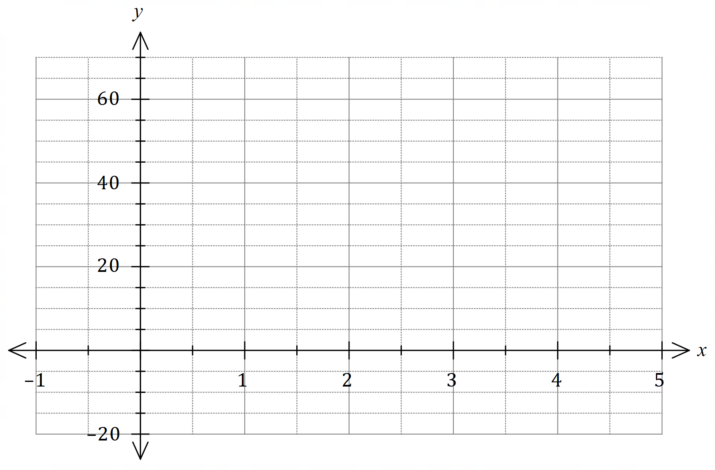

Question 12 (8 marks)

Data from repairs to $495$ smartphones showed that $340$ were Android and the remainder iOS. The type of repair was classified as screen or other, and of the $346$ smartphones that required screen repairs, $265$ were Android.

(a) Determine, to $3$ decimal places, the probability that a randomly selected smartphone from those repaired

(i) was an iOS smartphone. (2 marks)

(ii) required a screen repair or was an Android smartphone. (2 marks)

(iii) was an iOS smartphone given that it required a screen repair. (2 marks)

(b) Use two of the above probabilities to explain whether the repair data indicates possible independence of type of smartphone and type of repair. (2 marks)

Question 13 (7 marks)

An aeroplane takes off from an airport situated at an altitude of $150$ metres above sea level and climbs $450$ metres during the first minute of flight. In each subsequent minute, its rate of climb reduces by $4\%$.

(a) Determine the **increase in altitude** of the aeroplane during the fourth minute. (2 marks)

(b) Deduce a rule in simplified form for the **altitude $A_{n}$** of the aeroplane at the end of the $n^{\text{th}}$ minute. (3 marks)

(c) Determine the altitude of the aeroplane after $12$ minutes. (1 mark)

(d) Determine the maximum altitude the aeroplane can reach. (1 mark)

Question 14 (8 marks)

Two events $A$ and $B$ are such that $P\left(A\right)=0.35$ and $P\left(B\right)=0.48$.

Determine the following probabilities.

(a) $P(\overline{A∪B})$ when $A$ and $B$ are mutually exclusive. (2 marks)

(b) $P(A∪B)$ when $P\left(\overline{A}∩B\right)=0.25$. (2 marks)

(c) $P(A∩\overline{B})$ when $A$ and $B$ are independent. (2 marks)

(d) $P(A|B)$ when $P\left(B | A\right)=0.2$. (2 marks)

Question 15 (7 marks)

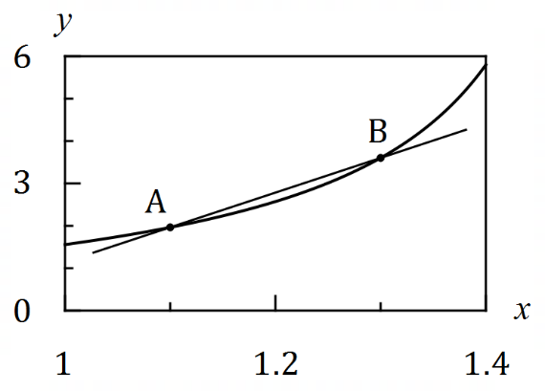Let $f\left(x\right)=\tan{x}$, where $x$ is measured  
in radians.

The graph of $y=f(x)$ is shown.

Two points, $A$ and $B$, lie on the curve with $x$ 
-coordinates $1.1$ and $1.1+h$ respectively,  
where $h>0$.

The secant through $AB$ is also shown.

(a) Use the difference quotient $\begin{matrix}δy \\ \overline{δx}\end{matrix}=\begin{matrix}f\left(x+h\right)-f(x) \\ \overline{ h }\end{matrix}$ to calculate, to $3$ decimal places, the slope of secant $AB$ when

(i) $h=0.2$. (2 marks)

(ii) $h=0.05$. (1 mark)

(b) Show use of the difference quotient to determine a better estimate, correct to $3$ decimal places, for the slope of secant $AB$ as the value of $h$ tends to $0$. (3 marks)

(c) Briefly explain how your answer to part (b) relates to a feature of the graph of $y=f(x)$ at the point $A$. (1 mark)

Question 16 (6 marks)

The sum of the first $n$ terms of a sequence is given by $S_{n}=3n^{2}+2n$.

(a) Determine $S_{5}$. (1 mark)

(b) Determine $T_{5}$, where $T_{n}$ is the $n^{\text{th}}$ term of the sequence. (2 marks)

(c) Explain why the sequence must be arithmetic and hence deduce a rule for the $n^{\text{th}}$ term of the sequence. (3 marks)

Question 17 (10 marks)

Particle A is moving along the $x$-axis so that its displacement, in cm, at time $t$ seconds, $t≥0$, is given by $x=5+2t-0.25t^{2}$.

(a) Sketch the displacement-time graph of particle A on the axes below. (3 marks)

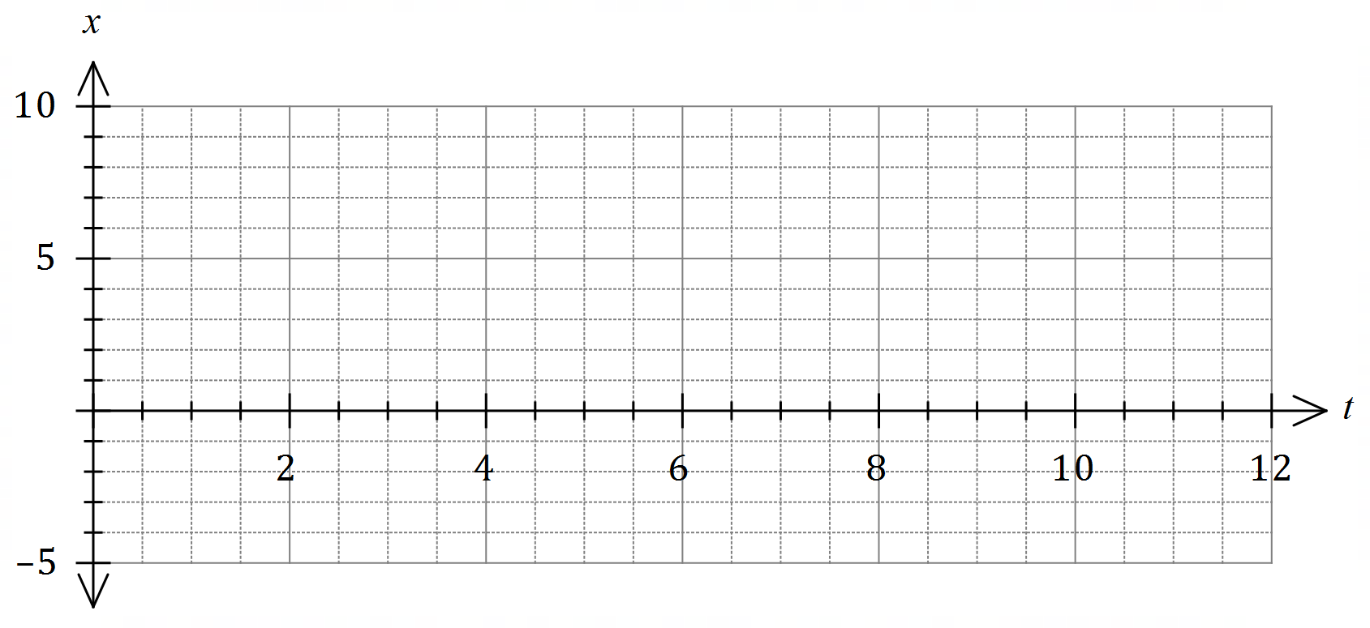

(b) Determine the velocity of particle A at the instant it reaches the origin. (3 marks)

(c) Particle B is also moving along the $x$-axis, but with a constant velocity. When $t=5$, it has the same displacement and velocity as particle A. Determine when particle B reaches the origin. (4 marks)

Question 18 (8 marks)

A random selection of $4$ spanners is made from a collection of $15$ different spanners,  
of which $6$ are metric and the remainder imperial.

(a) Show that the probability the selection contains all imperial spanners is $\begin{matrix}6 \\ \overline{65}\end{matrix}$. (3 marks)

(b) Determine the probability that the selection contains

(i) all metric spanners. (2 marks)

(ii) at least one imperial spanner. (1 mark)

(iii) at least one metric spanner and at least one imperial spanner. (2 marks)

Question 19 (7 marks)

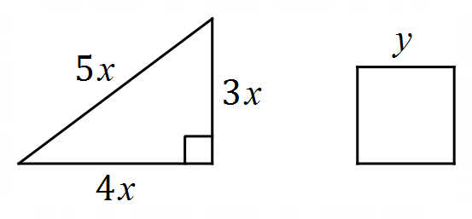A length of wire $72$ cm long is cut into two pieces.  
One piece is bent into a right triangle with sides  
of length $3x, 4x$ and $5x$ cm and the other piece  
is bent into a square of side $y$ cm.

Formulate an expression for the combined area of the triangle and square in terms of $x$ and hence use calculus to determine the minimum value of this total area.

Question 20 (10 marks)

Three small weights $A, B$ and $C$, each attached to a spring, are oscillating vertically above level ground. The height, $h$ cm, above the ground of each weight at time $t$ seconds, $t≥0,$ is given by

$$h_{A}=15\sin\left(\begin{matrix}πt \\ \overline{ 3 }\end{matrix}\right)+35, h_{B}=14\cos\left(\begin{matrix}2πt \\ \overline{ 3 }\end{matrix}\right)+30, h_{C}=15\sin\left(\begin{matrix}2πt \\ \overline{ 3 }\end{matrix}\right)+30.$$

(a) State which two weights are oscillating with the same amplitude, and state what this common amplitude is. (2 marks)

(b) State which two weights are oscillating with the same period, and state what this common period is. (2 marks)

(c) State which of the weights reaches closest to the ground and state the time at which it first reaches this position. (3 marks)

(d) Determine the length of time (to 3s.f) during the first $6$ seconds for which $h_{B}>h_{C}>h_{A}$. (3 marks)

Question 21 (9 marks)

The graph of the hyperbola $y=\begin{matrix}a \\ \overline{x+b}\end{matrix}$ is shown below, where $a$ and $b$ are constants.

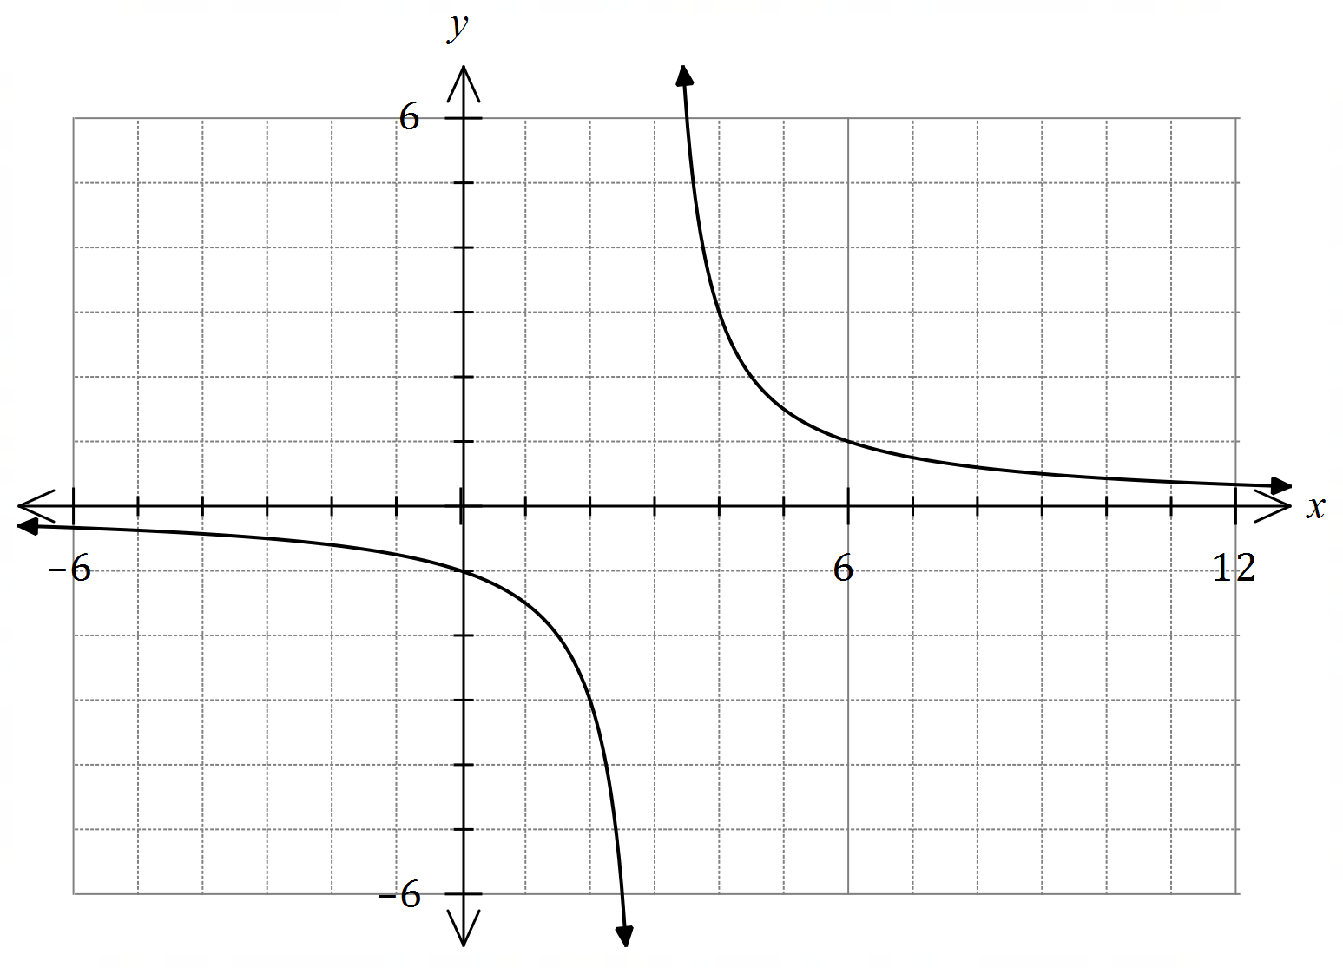

(a) State the equations of all asymptotes of the hyperbola. (2 marks)

(b) Determine the value of $a$ and the value of $b$. (2 marks)

(c) Add the line $y=2x+3$ to the graph of the hyperbola and state the number of points of intersection it will have with the hyperbola. (2 marks)

(d) The line $y=mx+3$ is tangential to the hyperbola, where $m$ is a constant. Use an algebraic method to determine all possible values of $m$. (3 marks)

Supplementary page

Question number: _________

Supplementary page

Question number: _________

© 2021 WA Exam Papers. Kennedy Baptist College has a non-exclusive licence to copy and communicate this document for non-commercial, educational use within the school. No other copying, communication or use is permitted without the express written permission of WA Exam Papers. SN245-182-2.